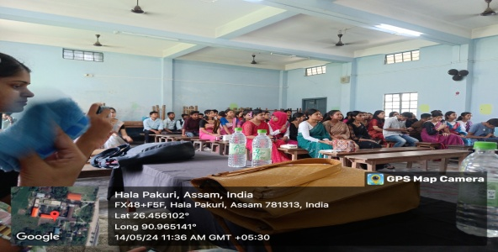Departmental farewell for the PG 4th semester and UG 6th semester held on 14th May, 2024 at Room No- 14, B.H.College, Howly. All students and teachers of the Department of Education were present in the meeting. Dr. Bhushan ch. Pathak, Principal, B.H.College delivered the speech as a special guest and encouraged the students to prepare for future to become a responsible member of the society. 